# **Elevating Hospitality with AI-Powered Guest Experiences**

In a recent episode of *The Future of Hospitality*, we explored the growing role of artificial intelligence in revolutionizing guest services within boutique hotels and vacation rentals. As personalized experiences take center stage in modern hospitality, AI is revolutionizing how property managers and guests engage. This shift allows hotels to deliver faster, more accurate, and personalized responses to guests' needs while streamlining operations behind the scenes.

## **The Power of AI in Hospitality**

The Power of AI in Hospitality


AI isn’t just about futuristic solutions—it’s about enhancing the guest experience in practical ways today. Certainly! Here is the text in an easier-to-read format:

Whether it’s offering multilingual support, providing personalized local recommendations, or automating service requests, AI concierge assistants, such as msg2ai’s solution, are transforming how hotels interact with guests. Imagine a guest arriving late and needing dinner recommendations that match their tastes. The AI assistant can instantly suggest the perfect location, communicate in the guest's native language, and even handle the reservation.

## 

## **Personalized, 24/7 Guest Support**Personalized, 24/7 guest support and Streamlining Operations

At the heart of msg2ai's AI Concierge Assistant is the ability to offer 24/7 support across various communication platforms, including SMS, WhatsApp, and Telegram. Gone are the days when guests had to rely solely on the front desk. With msg2ai, they can request services, inquire about amenities, or even book local attractions—all through simple text messages. This continuous, intelligent support enhances the guest experience while allowing hotel staff to focus on more personalized, in-person interactions.

## **Streamlining Operations for Hotels**

The AI Concierge Assistant offers property managers an effective solution by enhancing guest satisfaction and optimizing operational efficiency. The assistant automates routine tasks, from answering common questions about check-in procedures to handling service requests for room cleaning or maintenance. With fewer calls to the front desk, staff can redirect their attention to other important service areas, leading to smoother operations and more satisfied guests.

Additionally, automation reduces operational costs by minimizing the need for large front desk teams and eliminating the need for printed guestroom booklets. This ensures that guests have access to the latest information on local events, tours, and dining options—offering hotels valuable upselling opportunities.

## **Data-Driven Insights**



Another key advantage of msg2ai's solution is its ability to collect real-time guest feedback and offer data-driven insights. Property managers can use this information to continuously improve their services, tailoring their offerings based on guest preferences and behavior. This not only enhances the guest experience but also increases the chances of receiving positive online reviews, further improving the hotel’s reputation.

## **Transforming Boutique Hotels with AI**

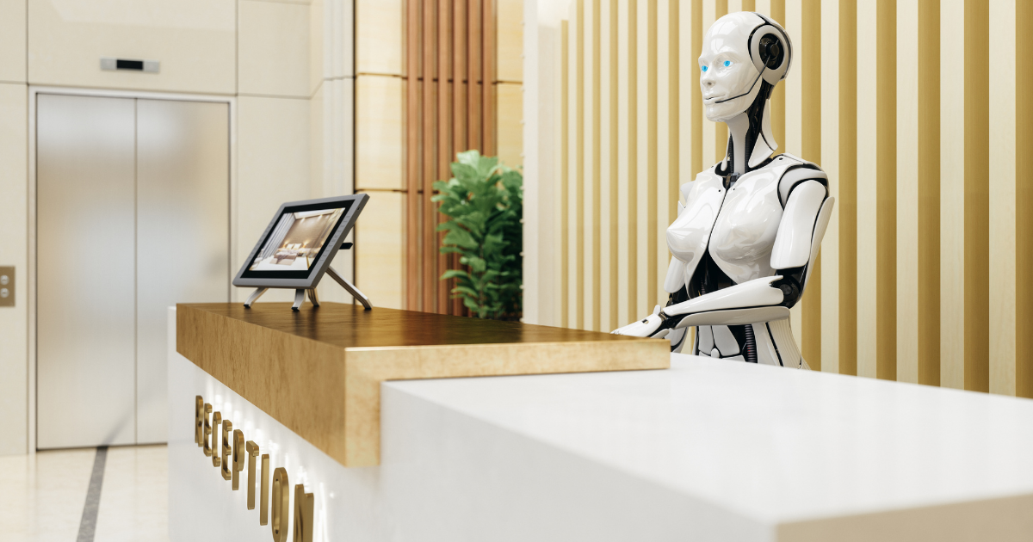

As discussed in our latest podcast, AI is not just for large hotel chains. Boutique hotels and smaller properties can benefit as much, if not more, from integrating an AI concierge assistant. With msg2ai, properties of all sizes can provide a consistent, high-quality guest experience that keeps travelers returning. By seamlessly integrating with existing property management systems, msg2ai’s solution ensures a smooth transition into the future of hospitality.

### Conclusion: A New Era of Guest Service

The future of hospitality is here, and it’s powered by AI. Whether it’s providing around-the-clock support, offering personalized local recommendations, or helping hotels reduce costs, AI solutions like msg2ai's Concierge Assistant are set to revolutionize the industry. It’s time for boutique hotels to embrace this technology and elevate their guest experiences to new heights.

To learn more about how AI can enhance your property’s guest services, contact us at msg2ai and discover how our AI Concierge Assistant can make a lasting impact on your hospitality business.